Missionaries and Cannibals
Aim:
To solve the Missionaries and Cannibals problem.
Objective:
To safely move all missionaries and cannibals across the river.
Algorithm:
- Represent states.
- Generate valid moves.
- Avoid unsafe states.
- Reach goal state.
Flowchart:
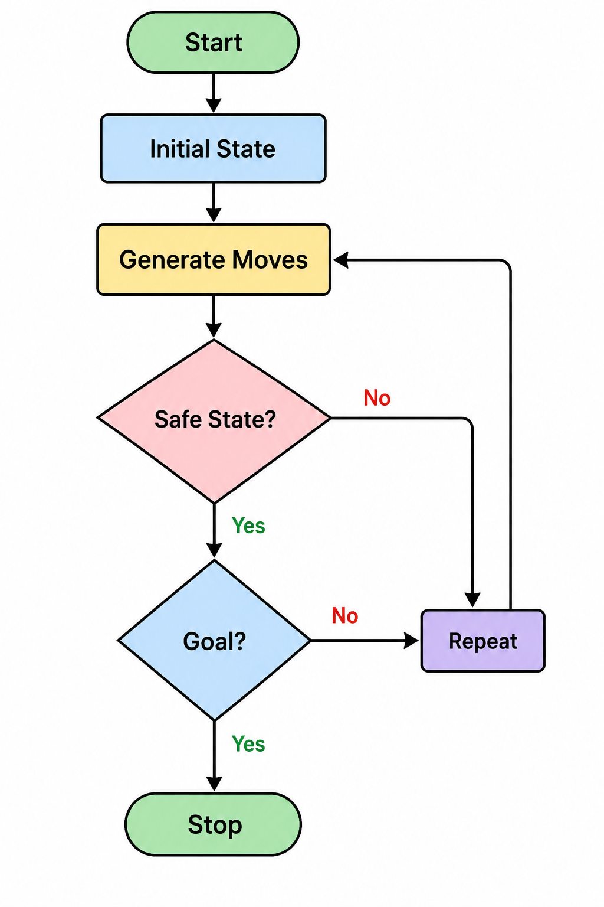
PYTHON CODE: print("Missionaries and Cannibals Solution")

n = int(input("Enter the number of states: "))

states = []

for i in range(n):
state = input(f"Enter state {i+1}: ")
states.append(state)

print("\nMissionaries and Cannibals Solution Path:")

for s in states:
print(s)
OUTPUT: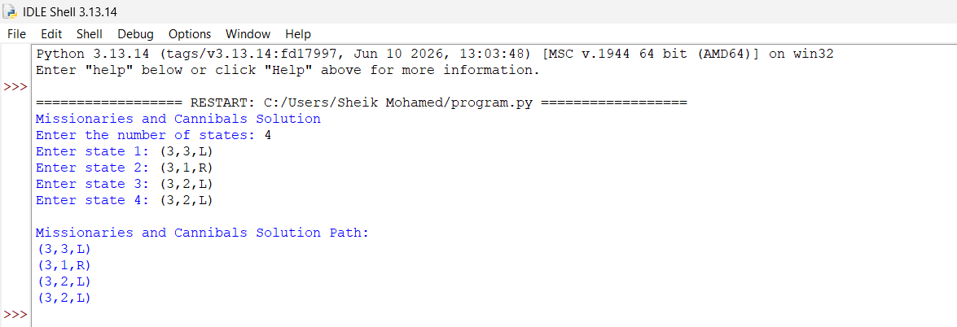
Result
All missionaries and cannibals crossed safely.
Conclusion
The problem was solved using state-space search.

